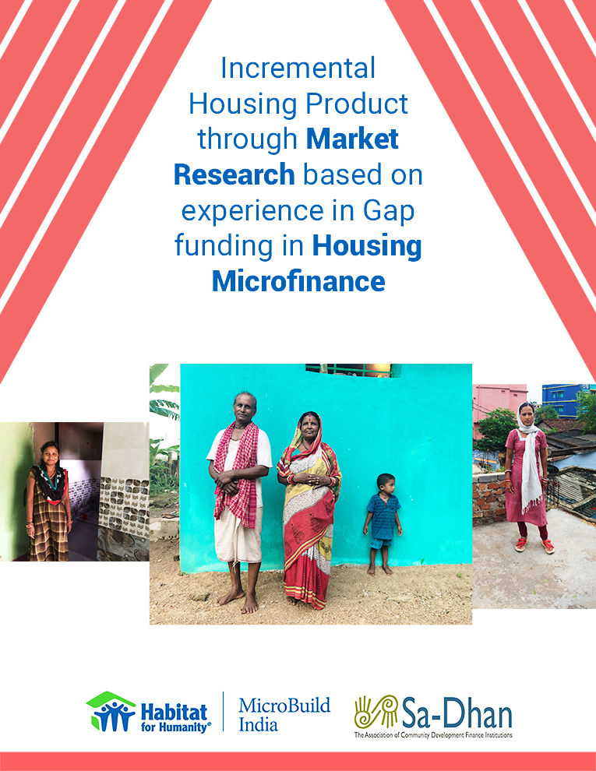

Table of Contents

Acknowledgement 3
Abbreviations 4
Introduction 5
Market Potential 7
Experience in Housing Finance to EWS and LIG segments 9
Constraints on the Supply side 13
Regulatory constraints 13
Funding-related constraints 13
Operational constraints 14
Constraints on the Demand side 15
Limited Repayment Capacity 15
Property Documentation 15
Need for Client Awareness 16
Segments in Low Income Housing Finance 18
Market Assessment Findings 22
Incremental Build Product Guidelines 26
Housing Microfinance – Unsecured Home Improvement Loan Product 26
Micro-mortgage – Secured housing loan product 28
Incremental Build Guidelines - Technical 33
Policy Recommendations 36
Conclusion 45

Acknowledgement

We are very thankful to industry experts who have given their opinion and honest take, on the issues faced and possible ways to move forward.

Special mention needs to be made of Mr. GSV Ramu, independent consultant and industry veteran who reviewed and gave inputs on the output.

Thanks to Mr. Rajan Samuel, Managing Director of Habitat for Humanity India and Mr. Ramchandra Vaidya, ED and CEO of Habitat Micro Build India for their inputs and support.

Grateful to the Sa-Dhan team for this opportunity, their inputs and support all the way.

Henrietta Isaac
Head - Technical Assistance Services
Habitat Micro Build India

Abbreviations

AHFC | Affordable Housing Finance Company
CB | Credit Bureau
CIBIL | Credit Information Bureau India Ltd, now TransUnion CIBIL
EMI | Equated Monthly Instalments
EWS | Economically Weaker Sections
FCDO | Foreign Commonwealth Development Office. UK
HFC | Housing Finance Company
HIL | Home Improvement Loan
HMF | Housing Microfinance
HSS | Housing Support Services
JLG | Joint Liability Group
KYC | Know Your Customer
LIG | Low Income Group
MFI | Microfinance Institution
MIG | Middle Income Segment
NBFC | Non-banking Finance Company
NHB | National Housing Bank
NOC | No Objection Certificate
PLI | Primary Lending Institution
PMAY | Pradhan Mantri Awaz Yojana
SARFAESI Act | Securitisation and Reconstruction of Financial Assets and Enforcement of Security Interest Act, 2002
SFB | Small Finance Bank

Introduction

This study was commissioned by Sa-Dhan as part of a Foreign Commonwealth Development Office (FCDO) project on housing for the Low Income Group and the EWS segment.

Objectives

The study aims to collate experience of various types of institutions who have been lending or have lent to the above segments. The aim is to present the constraints on the supply and demand side, real and perceived, from the perspective of the different stakeholders.

This is also meant to clarify the sub-segments within the LIG and EWS space for the purpose of housing, so as to put the varying experiences in perspective and ensure that everyone is speaking the same language. Based on the experience of Habitat for Humanity India and Habitat MicroBuild who have been working on promoting market-based solutions to improve access to housing, a set of guidelines for ‘Incremental Build’ product(s) have also been set out. These of course, will need to be customised based on the capability and type of institutions who would like to offer such products and being mindful of the range of clients they might be serving.

The intent is also to offer recommendations for advocacy among the different players involved in housing in a way that will open up doors and make the segment more attractive to new entrants, while also ensuring that it is robust.

Background and Context

Sa-Dhan, the Association of Community Development Finance Institutions has been actively promoting financial inclusion in India for nearly two decades now. Sa-Dhan has been advocating for microfinance among Regulators, Banks, Academic Institutions and Practitioners. Sa-Dhan has been engaged in creating an impact in housing for Microfinance clients for the last decade. Discussions with Microfinance Institutions (MFIs), Housing Finance Companies (HFCs) and the National Housing Bank (NHB) threw up several issues. Different types of entities had tried different models in housing finance. Sa-Dhan, with the support of Foreign Commonwealth Development Office (FCDO), with an integrated approach of strategy, policy-advocacy and client engagement is undertaking the task of scaling up of housing, that is affordable to the EWS segment to narrow the gap in housing shortage. Towards that end, the need for an experiential study and suitable product and models was felt.

MicroBuild India Technical Advisory Services (MBINDTAS) is the consulting arm of Habitat Micro Build India Housing Finance which is a housing finance company providing wholesale debt to Microfinance Institutions (MFIs). MBINDTAS helps Microfinance Institutions introduce and lend Housing Microfinance loan products to their customers thereby improving their standard of living. MBINDTAS works closely with Habitat for Humanity International’s Terwilliger Centre for Innovation in Shelter (TCIS), a global knowledge hub which facilitates collaboration between public, private and other actors in the housing ecosystem worldwide

Defining the segment

Affordable Housing Finance now seems to range from loans of Rs.10 lakhs all the way to Rs.50 lakhs (property value of Rs.65 lacs). However, the segment being looked at here could be defined as the segment below the ‘Affordable housing’ segment, consisting of finance to EWS (with Annual Income of < Rs.3 lakhs) and LIG (with Annual household income between Rs.3 to Rs.6 lakh) groups. This would include loan of ticket sizes ranging from Rs.50,000 to Rs.500,000 for housing.

The Ministry of Housing & Urban Poverty Alleviation (2011) has categorised housing as shown below:

Category | Size (Sq. Ft of Super Built Up Area) | Equated Monthly Instalment(EMI)/Rent
EWS | Minimum 300 sq. ft./ Maximum 500 sq. ft. | Not exceeding 30-40% of gross monthly income of buyer
LIG | Minimum 500 sq. ft./Maximum 600 sq. ft. | Not exceeding 30-40% of gross monthly income of buyer
MIG | 600 – 1200 sq. ft | Not exceeding 30-40% of gross monthly income of buyer

Methodology

The first stage was a desk research on recent reports on Low Income Housing Finance in India and the world. This included looking at memos and circulars of NHB and RBI on the subject. This was followed by interviews with CEOs of a variety of financial institutions including NHB and other industry experts involved in housing in this segment. In order to gather qualitative information about the market for product design, 100 client interviews were carried out among 6 Microfinance Institutions across 3 regions. Besides, technical information was collected using an architect in Bhubaneswar.

Market Potential

Two thirds of the world’s emerging market population lives in substandard shelter. According to World Resources Institute 2007, the Bottom of the Pyramid spends about USD300 bn on housing – rent, repairs, loan repayments, etc.
Previous surveys in India and around the world have shown that about 20% of microfinance loans are being diverted for home repairs and improvements. The need is clearly visible.
According to the 11th five year plan (2007 – 2012), the number of housing units needed was 73.6 million in 2012. Out of this, 36% was urban and 64% rural. KPMG in its India analysis predicted in 2014, that this number would grow to 90 mn units by 2022. Out of this, 96% units are needed by the EWS (Economically Weaker Sections) and LIG (Lower Income Group) segments.
According to census 2011, only 19% of rural homes were pucca (built of RCC walls and roof - reinforced concrete). It is reported that 42 to 100 mn Indians live in slums. One can imagine the size of the gap in the market. In fact, the urban market for Rs.3 to Rs.10 lac homes alone is estimated to be Rs.1,100,000 crores as estimated by the Monitor group in 2010.
While the potential market is attractive, it would be apparent that improving quality of housing or increasing housing stock is not just about asset creation, but about enhancing the quality of lives of people several-fold. Research has proven that decent housing directly impacts health, education, employment, safety and societal unity, as can be seen in the graphic below.

- Improved health due to better sanitation, clean water
- Reduced spread of diseases
- Access to healthcare
- Improved psychological well being
- Access to employment
- Improved productivity
- Social support networks
- Greater community empowerment and participation
- Realization of dream
- Lower crime rates
- Revitalisation of neighbourhood
- Protectiono from natural disasters
- Higher achievement at school
- Continuity of education and employment
- Reduced negative impacts due to over-crowding, lack of security, stability
Benefits of improved housing

Source: Adapted from Mc Kinsey Global Institute Analysis

Figure 1: Benefits of Improved Housing

Experience in Housing Finance to EWS and LIG segments

Underserved market

The picture of the underserved market in 2010 is nearly the same as the underserved market now – the Rs.2 to 5 lakh ticket size segment.

Housing Microfinance in India

In 2009, a USAID project was won by Habitat for Humanity along with two partner organisations, to promote models of Housing Microfinance in the country. Apart from kick-starting housing microfinance in the country, this also led to the set-up of Habitat MicroBuild India, a Housing Finance Company focused on funding MFIs for rolling out housing microfinance to their client bases. This was further promoted by International Finance Corporation (IFC) and the National Housing Bank (NHB) in 2011, through the development of a toolkit for Housing Microfinance and Micro-mortgage. This also resulted in the IFC funding about ten organizations like the erstwhile Ujjivan Financial Services for development and rollout of Housing Microfinance.
From the experience of Habitat Microbuild India, as of Nov 2019, Rs.128 crores had been funded to 41,179 end clients in 209 districts across the country through 27 microfinance institutions. The partner microfinance institutions have in turn been able to use these loans and raise seven times more funds i.e., Rs.709 crores, lending to about 2,22,243 families. One of the mandates given to Habitat MicroBuild India, is to ensure that the funds lent by it are leveraged by the microfinance institutions to access more funds for housing.
Currently, the Home Improvement Loan portfolio of these institutions range from 1 to 9% of their Gross Loan portfolio. The ticket sizes of these unsecured loans are from Rs.20,000 to Rs.100,000. Interestingly, the PAR for housing for most of these institutions has been below 1%, which is a good sign, as can be seen below.

Figure 2: PAR for Housing Microfinance

Currently, about 17 to 20 Microfinance Institutions like Sonata, Annapurna, Margdarshak have about 2 to 9% of their portfolio in housing microfinance.
Small Finance Banks (SFBs) like Ujjivan Bank have a portfolio of about Rs.1,550 crores in secured housing loans. This does not include their housing portfolio in their microfinance vertical. Other Small Finance Banks however, seem to be trying to reconcile being a bank with continuing to cater to their original microfinance client base.

Select Affordable Housing Finance Companies like Svatantra MHFC (Portfolio Rs.700 cr) and Sewa Grih Rin, now Sitara (Portfolio Rs.200 cr) have, from inception been targeting the Low Income Segment with customized housing products and models to keep operational cost low.
Swarna Pragati pioneered a model of working in partnership with small NGOs and reaching out to the Self Help Group client base in this country. They also used alternate security like an extract from the Gram Panchayat to create a Registered mortgage. Chaitanya India Fincredit Pvt. Ltd. also used other creative alternate security, in order to make the product relevant for the Low Income segment.

Why Housing Microfinance?

Microfinance institutions across the world explore housing microfinance for the following main reasons:
- Demand from clients for housing and home improvement
- Visible impact in terms of improved security and dignity of life
- Portfolio diversification
- Help build loyalty by meeting the needs of clients who have graduated out of group loans
Apart from the above, housing fits into the lifecycle of a client – i.e., the client starts with microfinance loans which help grow her income. As the family and income grow, there is need for increased space or better housing, thus creating a demand for housing-related products.

The biggest challenges faced internationally by the MFIs that had taken up housing microfinance according to the same survey were unavailability of land or title and lack of funds. Other challenges included lack of institutional capacity to meet demand and government regulation.

NPA in Housing

One issue that keeps coming up when discussing housing is the rising level of NPA and some high profile cases of troubled players in the housing space. It is therefore only fair that one should take a good look at this issue.

According to RBI, (June 2018 Monetary Policy) the level of NPA in housing for ticket sizes less than Rs. 200,000 – primarily Housing Finance Company loans was rising. NPA for home loans less than Rs.200,000 had increased from 9.8% to 10.4% during 2015-16 and 2016-17.

However, as per an ICRA report, the high NPA was the result of demonetisation during this period. It is only understandable that such systemic shocks, apart from unexpected health-related problems and accidents are bound to hit the vulnerable population harder.

One Housing Finance company which focused mainly on the EWS and LIG segments was badly hit by demonetisation, so much so that they decided to change the operating model that was pioneered by them. It also led to the exit of its promoter from active leadership.

An NBFC which was offering secured housing products to the BoP market has since changed its business model. This was because they felt that the product was not attractive enough for scaling up and not because of NPA. There was also change in ownership, which would have influenced their decision.

Other institutions reportedly sailed through demonetisation– primarily efforts were made to keep EMIs low with longer loan terms, supported by proper Asset and Liability management.

Poised to go deeper

Institutions like Shubham Affordable Housing Finance Company (AHFC) and MAS started out a little over a decade ago, faced with the challenge of information asymmetry in the income of the Bottom of the Pyramid. Having mastered ways to deal with it, their combined portfolio has grown from Rs.100 crores ($ 20 mn) in 2013 to a phenomenal ₹27,000 cr ($4.1+ billion) in 2017. They have led to 230,000 affordable homes - this is not including Repco, DHFL. The average ticket size of these organisations is about ₹9.3 lakhs ($14,350). Now the good news is that, some of the Affordable Housing Finance Companies like Shubham and a few SFBs like ESAF and Jana Bank are looking to reach deeper into the market, while trying to gauge the level of risk and costs involved.

Constraints on the Supply side

Regulatory constraints

Regulatory restrictions are based on how the organization is set up.

NBFC MFIs

In NBFC MFIs, 15% of their portfolio can be assets that do not fall under ‘qualifying assets’ lending. This gives room for diversification into new products. Also, up to 50% of their portfolio can be non-income generation loans. However, a good portion of these will need to follow guidelines regarding priority sector lending, like being unsecured loans, margin restricted to 10%, total indebtedness of the borrow not more than Rs.100,000, etc. Regular funds sourced from banks can be used for onward lending for housing under this category

Housing Finance Companies

If set up as Housing Finance companies, according to the new guidelines by RBI, 50% of the total assets need to be individual housing loans. Now, SARFAESI is an Act that applies to loans above Rs.100,000 given out by Housing Finance companies. This Act enables institutions to take over property secured as collateral, without having to go through a court of law, which makes the process of recovery much less cumbersome and expensive. However, SARFAESI Act does not apply to NBFCs.

Funding-related constraints

Funds are normally available from public sector or private banks – unless they are specifically earmarked for income generation or agri loans. There are very few Housing Finance Companies and Banks that do lend exclusively for housing, for on-lending to the microfinance clients. However, since this segment is considered as high risk, the cost of source of funds is likely to be high. Refinance from National Housing Bank, which is at a very reasonable rate however, is only available to Housing Finance companies and that too, only for secured individual loans.
The term of the loans to end clients should be in synchrony with the term of the source of funds. If offering long-term loans – i.e., for over 5 years, institutions need to ensure the term of their source of funds corresponds to that, in order to ensure that there is no Asset-Liability mismatch. This therefore makes it challenging for NBFCs to lend for terms longer than 4 to 5 years.

Operational constraints

Cost of Operation
Considering the lower ticket size, the operational cost is high. Effort and therefore cost of client acquisition and processing is high from Housing Finance or Banking perspective, making it unattractive to large players.

Credit Risk Assessment

Rigorous credit assessment would be needed since the clients in this segment are not likely to have proof of income. However, MFIs and even Affordable Housing Finance Companies have mastered this art. Pricing based on risk would be necessary. However the general expectation is that these loans will need to be priced at a rate that makes them affordable. It would be difficult for organizations to find the balance.

Demand Aggregation

It would be necessary to find a suitably large number of clients close to each other, for the model to make economic sense. While urban neighborhoods lend themselves to this, rural pockets do not. Housing Finance Companies that are in this space seem to use sourcing agents to find the right clients.

Paradigm shift needed in MFIs

Housing Microfinance loans would work best as individual loans. While venturing into individual loans, MFIs will need to move away from the ‘group’ mentality, keeping in mind that these larger loans will be relying entirely on the client’s cash flow and not on the ‘group guarantee’. This will need a completely different perspective not just among field and processing staff, but in the management as well. Housing Microfinance specialists will be needed to set up appropriate systems and processes, to make the individual loan product robust. However, once set up, the processes would help the organization to step up to other similar individual loan products.

Constraints on the Demand side

Limited Repayment Capacity

Internationally housing related costs (EMIs, rent costs, etc.) are estimated to be at 30% of an affordable housing client’s monthly income to be affordable.
The typical income range of clients who are eligible for a home improvement loan is from Rs.20,000 to Rs.50,000 per month. This would be at the top end of EWS segment and lower end of the LIG segment. This would ensure that the client is able to service more than one loan – the home improvement loan would normally be a second loan in addition to a basic JLG (Joint Liability Group) loan to manage regular cash flow.
On account of the vulnerable nature of this segment, systemic disruptions like demonetization and lockdown could severely impact income. Apart from that, a single event like ill-health or an Act of God peril like flood, cyclone, etc. could affect continuity of income.
Subsidies could help make products affordable to this segment. It would also be important to ensure that Risk transfer measures like Insurance and Credit Guarantee Schemes are used appropriately to provide coverage to the household.
It would however be important to note here that people tend to be sentimentally attached to their homes – more so in this segment and therefore are likely to take all steps necessary to avoid default.

Property Documentation

This tends to be more of a structural issue and needs to be tackled at the state level, land being a state subject.

Ownership documentation

Overall about 86% of households live in houses owned by them, even if they do not have registered documentation to prove it. These documents might include patta or unregistered deed in the name of a deceased family member. This is often on account of cost of registration being prohibitive in most states (2 – 6% on value of property) unlike in Jharkhand, where it was Rs.1, if registered in the name of a woman or in MP, Chattisgarh or Gujarat where there are rebates on stamp duty for this segment.
In the case of households where government gives land with patta, it is often non-mortgageable. Apparently even land given under Jaga Mission in Odisha is not mortgageable, since it is non-transferable.
Where households do not have ownership, they are likely to have secure tenure or the legal right to stay for a defined period of time, which will be shown by the document(s) they might have – eg., tax receipt for people living on temple land, people living in authorized slums.

Approved Plan

Even households with registered sale deed are not likely to have approved plan for their property, which is required by some states, due to lack of awareness or inability to obtain approval after construction. In some locations, local guidelines might require an approved layout plan.

Need for Client Awareness

We see a lot of unfinished homes, especially in the Low Income segment. From our experience we see that clients almost always start out with the intention of spending 3 – 4 times the loan amount they have received. They are of the opinion that since a house is a ‘one-time asset’ and once-in-a-lifetime-doing and it is something they would leave behind for their next generation, they should put everything into it. In most cases, there is no budget in mind or planning. They simply use the loan amount to kick-start the project and take things as they come, bringing in funds from all available sources, until it blows out of proportion and comes to a sudden stand-still. Households also rely heavily on local masons who in fact ensure that the project keeps growing, for their own benefit. Therefore, in order to keep the home improvement or housing project to a manageable size, it would be necessary to create awareness among clients and masons about the need to limit spending to the loan amount.
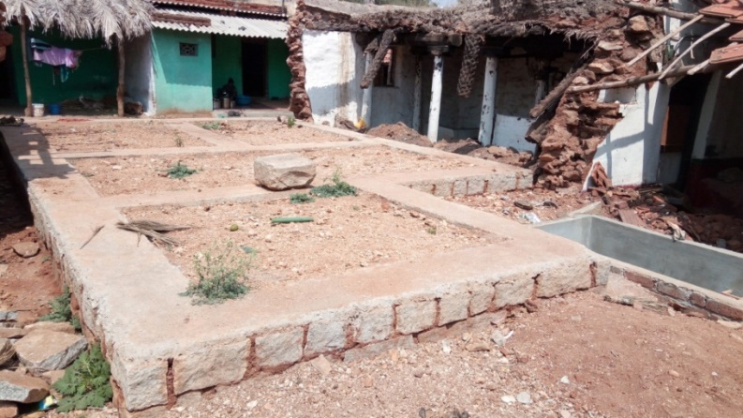
Figure 3: Unfinished home

Figure 4: Loan amount vs Amount spent
In an in-depth study carried out in two Microfinance Institutions, here’s what was found:
- When comparing loan amount with amount spent according to an engineer who visited each home, only 7 out of 50 clients interviewed had limited their spending to the loan amount + / - 20%.
- Clients’ budget (the amount they planned to spend) in approximately 64% of the cases (approx.) was several times the loan amount.
- About 46% of clients interviewed could not use the improvement or could only use a part of it, since it was not complete. This would mean more borrowing perhaps from other sources, posing a credit risk for the lending institution
- 94% of clients interviewed admitted that they had not planned for the improvement, or decided to take up all improvements in one go
- Repayment capacity was limited (73% could repay Rs.2,000 to Rs.5,000 pm) – which translated to loan of about Rs.60,000 to Rs.1.5 lakhs
In the light of the above, clients will need to be counseled upfront on the need to build in stages in order to limit the cost of house construction or improvement to the loan amount.

Segments in Low Income Housing Finance

While we think of the Bottom of the Pyramid as one big segment, when it comes to housing and housing finance, there are really several segments with varying capacities and housing needs within it as can be seen below.
 | Transitional Housing Client | Home Improvements, Incremental Build Client | New Housing Client
Nature of Buildings | Temporary and flimsy | Kutcha / part pucca / fully pucca | Pucca house
Ownership of land | Mostly encroaching, land that belongs to others or to the government | Has stability of tenure. Might or might not have legal rights to the land | Have a legal document
Housing Needs | Need a subidised house | Home improvements and additions – room, roof, toilet, core house, finishing, water and sanitation, rental deposits | Purchase or construction of new house by self or developer. Improvements tend to be larger ticket size

Source: Habitat for Humanity International
The above segmentation can be better understood from the cross-cut pyramid below:

Cross-cut Pyramid
Figure 5: Cross cut Pyramid
Source: Terwilliger Centre Handbook, Habitat for Humanity International
As can be seen from the pyramid above, only a very small portion of the population (the small triangle at the very top) in a developing economy such as ours has access to regular mortgage. The vast segments below have the potential to be served by a variety of customized products and services. Out of these, the red triangle on the right represents those with formal title, with the rest having informal titles to land. The green triangle on the left represents those with formal income, with the rest having informal income sources, which is a market largely serviced by Microfinance institutions. It is now an accepted fact that about 20% of microfinance clients already use their loan for home improvement loans.
Out of the Bottom of the pyramid in India, 82% (129.5 mn households) would fall into the LIG segment with an annual income of Rs.3 to Rs.6 lakhs (USD 4,100 to 8,200), 6% (9.6 mn households) fall within the EWS segment with an annual income of less than Rs.3 lacs and the remaining 12% in the MIG segment with annual income of Rs.6 to Rs.18 lakhs The top part of the EWS segment and lower part of the LIG segment would qualify for housing microfinance loans, while the top part of the LIG segment would be suitable for micro-mortgage loans.
Housing microfinance (HMF) is a subset of microfinance designed to meet the housing needs and preferences of low-income groups, especially those without access to the banking sector or formal mortgage loans. HMF is designed for low-income groups who wish to expand or improve their dwellings, or to build a home in incremental steps (progressively) relying on sequential small loans.
Housing Microfinance follows the principles of microfinance and adapts it to meet home improvement needs, thereby offering something that is familiar, yet effective.
 | Microfinance | Housing Microfinance
Purpose of Loan | To start up or expand micro business | To renovate, upgrade or incrementally build a house or meet other housing needs
Productivity of loan for borrower | Productive | Asset-building. Productive only when linked to livelihood
Loan Term | Short term: 6 months to 2 years | Medium term: 2 to 5 years
Loan Size | From Rs.10,000 to Rs.50,000 (USD 135 to USD 685) based on cycle | From Rs.30,000 to Rs.150,000 (USD 410 to USD 2,055) based on client’s need and repayment capacity
Loan Type | Group loan | Typically individual loans
Title to land | Not applicable | Some type of document confirming de factor claim to the land or the property (purchase deed or in certain cases a utility bill or tax receipt)
Collateral | Unsecured. Group guarantee used as collateral substitute | Unsecured. Co-applicants and guarantors used as collateral substitute.
Income and repayment capacity | Field verification and basic cash flow analysis by financial institution | Field visit to determine the client’s construction proposal and cash flow analysis by financial institution
Loan utilization | Difficult to track loan utilization | Easier to track loan utilization with proper monitoring

Source: Adapted from Habitat for Humanity’s Toolkit for Low Income Housing Finance for India
With Housing Microfinance, there was potential to tap into the Microfinance client base of 64 million women. About 30% of these households are likely to graduate into a larger home improvement loan, which will help with client retention. Nearly 5 to 10% clients will be eligible for micro-mortgage loans for new housing. This would promote women-inclusive housing-related decision making, which will impact the family as a whole.
Housing Microfinance improves the quality of life of clients by improving aspects of their housing. For instance, a significant portion of houses in the country have sub-standard roofing or have mud walls or mud flooring. Improving just one aspect – for instance, converting the floor from potentially disease-causing mud to cement or the roof from cement sheet to more stable RCC roofing could protect the family from a range of diseases. The 2011 census also showed that nearly 40% of the households in the country had only one room, to be shared with as many as five members (national average), which when improved could improve health, physical and mental making the homes safer and more live-able.
Typically housing microfinance clients are told upfront that the loan is not suitable for building a new house from scratch and is more suitable for improving the house in stages.
Micro-mortgage includes housing loans of long duration (generally ten years or more) that exhibit all characteristics of traditional mortgage loans (long repayment period, house as collateral for the loan, ability to foreclose and sell the house in case of default) and are small enough that they can be afforded by poor and very poor households.
Here is how micro-mortgage differs from market-based mortgage loans.
 | Mortgage | Micro mortgage
Target population | Organized sector, salaried class (Middle Income Group and High Income Group) | Top end of unorganized sector and lower end of salaried class (Lower Income Group)
Loan Term | Long term: 15 – 25 years | Medium term: 5 – 15 years
Loan Size | From Rs.1,000,000 to Rs.150,00,000 (USD 14,000 to USD 205,000) based on value of the property and repayment capacity | From Rs.200,000 (USD 2750) to Rs.700,000 (USD 9,750) based on value of the house or apartment and repayment capacity
Client Selection | Based on client’s repayment capacity, supported by documentary evidence. Sophisticated credit scoring done using statistical modelling. | Entirely based on client’s household cash flow, supported by available documentary evidence and field verification. Risk rated based on source of primary income (client profiling)
Client Awareness | Clients generally literate and aware of risks involved | Important to educate clients on risks of over-borrowing and on product features
Loan Utilization | Loan released in tranches for construction directly to promoter, where applicable | Loan released in tranches for construction. Predominantly owner-led construction
Transaction cost | Low – large loan size with low cost paper-based credit appraisal mechanism | High – smaller loan size with relatively expensive field-based credit appraisal mechanism
Price of loan | Standard. Mostly floating rates | Higher. Can be floating rates, but needs to be explained to clients clearly

Source: Adapted from Habitat for Humanity’s Toolkit for Low Income Housing Finance for India
Micro mortgage loans are of longer duration and present characteristics of traditional mortgage loans like long repayment period, house as collateral, foreclosure, etc.
On a spectrum, microfinance would be followed by housing microfinance of larger ticket-size and medium term, moving on to micro-mortgage of longer-term and larger ticket sizes and end with mortgage loans. Therefore, it would be natural for Microfinance Institutions to move from microfinance onto housing microfinance, while it would be more practical for Housing Finance Companies and Banks who are already doing mortgage loans to move down to offering micro-mortgage loans on their own or in partnership with an MFI.

Market Assessment Findings

Income

When comparing income, except for a few outliers, in most of the cases, for clients with unsecured housing microfinance loans, the income was in the range Rs.15,000 – Rs.40,000. Housing EMIs were within affordable EMI limits at 30% of income. However, total EMIs from all borrowings for the same clients exceeded affordable income in some cases.
In the case of secured housing loan clients however, the income levels were higher as can be seen by the graphs below, with housing EMIs close to affordable EMIs. Total EMIs seemed to exceed affordable EMIs. This could be avoided by increasing the term of the loan (most of these loans were within 5 years), thereby reducing the EMI.

Figure 6: Actual vs Affordable EMI - Unsecured and Secured Loans

Loan purpose

The most common purposes for unsecured housing microfinance loans were plastering, flooring, painting – i.e., finishing (the most common need) followed by roof repair or roof change, room addition, new construction and water and sanitation loans. In the case of secured housing loans, the purpose of the loan was to a large extent home extension, roof repair, roof change to RCC and new house construction, with home extension and roof repair being equally common.

Planning and Budgeting

When comparing loan amount with amount spent, here’s the picture that emerged. Irrespective of the loan amount, the amount spent seemed to be several times the loan amount, sometimes even up to seven times. This seems to show that simply increasing the loan amount was not likely to solve the issue of households over-spending when it came to housing. Only 50% of clients interviewed had started the home improvement or construction project with an estimate of how much it was going to cost them.

Figure 7: Loan Amount vs Amount spent - Unsecured and Secured Loans
In fact, 5% of the clients interviewed did not know how much had been spent. Almost all clients had plans for further improvement using future loans, suggesting that the improvements or construction were not complete and that there was scope for repeat loans i.e., cycles. Also, client assumption of their own affordable EMI ranged from 1 to 5 times actual affordable EMI.

Ownership Documentation

Awareness was low among clients about the nature of documents available with them. Most of the unsecured clients had patta or unregistered documentation in the name of deceased family members, for property that had subsequently been partitioned and therefore were not interested in giving their documents as collateral.
On discussing with the stakeholders in housing finance for the low income group, all of the institutions admitted that access to land records was a huge challenge and was primarily responsible for stopping them from going deeper down the market. In rural areas, the question to be raised was if the property was agricultural land and if there was permission to build housing on it. In the eastern states, one had to check with the forest and tribal department to see if housing was allowed. In order to avoid these issues and to be able to find more clients in one location, two of the Housing Finance Companies and one Small Finance Bank with experience in this segment focused on urban or semi-urban areas. In urban areas, while working with the EWS living in slums, it had to be checked if they were authorized slums and what the local guidelines were, regarding housing in those areas.
To avoid running into legal issues, the following checks had been put in place by one HFC (Sewa Grih Rin) focussed on this segment:
- Check if rights could be transferred to the individual in their name
- Study ability to make property title completely legal
- Prepare a legal risk matrix
- Support client in creating legal property title and then give loan, which would have longer term impact and build security
A few other institutions had found creative ways of finding and using ‘alternate’ security in the following forms:
- Document from Gram Panchayat (eg. Form 9 & 11 in Karnataka) as proof of ownership and by involving the community and use it to create a registered mortgage. This was accepted by the National Housing Bank, the erstwhile regulator for Housing Finance companies, but not accepted for refinance.
- Create a mortgage using tax receipt, register the mortgage, which would itself become the title deed. This too was accepted, but not for refinance.
- In an urban setting, if a client had the original document that could prove secure tenure (the right of the client to stay there) and could be transferred to their name, one could get a ‘No Objection Certificate’ from the local body or Nagar palika and create an equitable mortgage . This was accepted for refinance.
- Use patta or LRC (Land Right Certificate in Odisha) to create a mortgage and register it. While this was accepted, it needs to be checked if refinance would be available against such mortgage. While this would create an ‘encumberance’ in the Encumberance Certificate by not allowing the client to take out another loan on the same property or sell it, it would not be ‘transferable’ in the real sense of the term – i.e., not allow the financial service provider to take the property over and dispose it off to recover a loan in the event of default.
- Another innovative mechanism would be to get an ‘Occupancy certificate’ from the village sarpanch citing that the homeowner had lived there for x number of years, create a gift deed detailing borders of property and photos of donor-donee. This deed could then be registered and a mortgage created. (It would be important to do this only within an MFI relationship where the institution is aware of the members in the community, so there is no scope for misuse.) This may be acceptable to NHB, as a title deed would be made available as security.
The above solutions supported by a personal guarantor in the client’s community would strengthen the credit lending mechanism and increase tendency for prompt repayment.
Institutions that were using the above methods of alternate security were managing their risk by limiting the percentage of loans given to households with non-transferable title, being aware of location-wise concentration of risk, co-originating through Microfinance Institutions and sharing benefits as well as risks with them. Ujjivan Small Finance bank treats loans without proper mortgage as ‘Home Equity’ Loans and does not consider them under individual housing loans.

Incremental Build Product Guidelines

Roughly 70% of the world’s population in developing countries access shelter through self-built ‘incremental’ or ‘progressive’ housing. (Ferguson, 2003) According to Micro Home Solutions, in India owners of incrementally built houses with income levels of less than Rs.15,000 represented nearly 40% of the population of Tier II and Tier III cities.

The kind of Incremental Build promoted by Habitat for Humanity however is the improvement or construction of a home which is done in phases, with each phase logically completed, so that it can be used by the household.

Habitat for Humanity uses the 8 Ps of marketing – Population, Place, Price, Product, Promotion, Personnel, Process and Positioning to define the product.

Housing Microfinance – Unsecured Home Improvement Loan Product

Detailed below are the recommended product features for Housing Microfinance, based on the market assessment from the client surveys and the stakeholder interviews.

Product features | For Home Improvement or Extension | Remarks
Purpose | a) Home Improvements or Extension – in phases  b) Finishing of house (plastering, painting)  c) Gap funding, if subsidy is available | Found to be more successful in a) Small home improvements and b) for finishing after construction is complete.
Population | Complete 1st cycle - known client  Housing Repayment capacity @15% Monthly Income;  Monthly income of Rs.20,000 or more | Similar to microfinance  15% conservative, assuming there will be at least 1 other microfinance loan (30% Monthly Income is global practice)
Product | Loan Amount: Rs.50,000/- to 100,000/- | Has been proven to be more successful below Rs.1 lac
EMI | Rs.2,000 to Rs.3,500 | Easily repayable EMI (Especially in light of regular disruption of economic activity)
Tenure | 24 – 60 months (not less than 36 m for Rs.1 lac) | Loan is for asset creation – linked to life of asset
Price | 20 – 24% (max)+ 1% processing fee + Insurance | Based on cost of funds.
Collateral Substitute | Unsecured Loan, Earning spouse, son or daughter as co-applicant, 1 – 2 Guarantors within or outside group, Cheques | To create social pressure to repay.  Individual, cash-flow based loan.
Promotion | Important to educate clients to spend within 120% of loan amount | Discourage large unwieldy improvements, to avoid over-borrowing.
Process | - Put in place a) Credit and b) Technical Appraisal mechanisms  - Loan utilisation checks to ensure completion  - Housing Support Services – Client counselling | Ensure that a) Client has sufficient repayment capacity and b) Loan amount is linked to housing need – help client plan for improvement in stages  (Customised processes will need to be built in MFIs)
Supporting Documents | - Copy of ownership document or document showing secure tenure (original to be verified) / Land Revenue or holding tax receipt | To ensure that loan is not for property that has risk of being demolished.

On account of regulation and access to funds, NBFC-MFIs are more suitable to lend short to medium term unsecured home improvement loans. Here are possible models in which these unsecured loans could be funded:
- MFIs on their own, after customised capacity building
- Wholesale lending, where the loans will be in the books of the MFI – Banks or HFCs to MFIs. These can fall within priority sector lending as well.
- Business Correspondence model where the loans will remain on the books of the Housing Finance Company – HFC with MFI after suitable processes have been put in place and training provided not just to field staff, but the management staff as well.
- Business Correspondence – between Small Finance Bank and MFI, where the SFB could use the MFI as sourcing and processing agent.
  - For Loans
  - For loans, savings, other products
This type of relationship between SFBs and MFIs could open up a whole new range of products for the MFI client base, taking financial services to the next level, while keeping them affordable for and customised to this segment.
Currently, National Housing Bank’s refinance is not available to this segment and therefore interest rates tend to be high and funding levels low.

Micro-mortgage – Secured housing loan product
Here are generic product guidelines for secured loans, for institutions that have the capacity and funds to implement them.
Product features | For New House Construction | Remarks
Purpose | a) Renovation, Extension or Purchase  b) Incremental Build starting with core house  c) Gap funding for clients eligible for PMAY subsidy | Client has need to rebuild or build from ground up
Population | Top 5 - 10% of JLG clients, clients outside of MFI client base; Housing Repayment Capacity @15% of Monthly Income; Monthly income of Rs.25,000 or more | This would be more LIG segment
Product | Rs.2 – Rs.5 lacs (80% LTV) disbursed in 2 tranches | Client to limit spending to 120% of loan amount
EMI | Rs.3,000 – Rs.8,000 | Easily repayable EMI (Most clients are likely to need additional business or consumption loans)
Tenure | 6 – 15 years (More than 10 years if loan is for >5 lacs) | Term can be based on strength of ownership documentation
Price | 13 - 18% + processing fee + legal and valuation cost + Insurance | Longer the term, lower the interest rate, to keep interest quantum low. Risk based pricing.
Collateral | Use revenue tax, LRC or patta and registered mortgage. When partnering with MFI, create gift deed and mortgage | Strive to keep legal and documentation expenses low. In any case taking over property in this segment would be undesirable. In addition, peer pressure through guarantor would be effective.
Promotion | Educate client on need to spend within 120% of loan amount (loan amount + 20% max); Implications of mortgage
Process | Rigorous Credit and Technical Appraisal; Valuation and Legal Processes in place, Loan Monitoring essential | Keep legal and valuation costs minimal
Supporting Documents | Mortgaged ownership-related documents | Use available ownership-related documents limiting % of portfolio, loan term and building necessary reserve.

It would be important to mention here that the following types of security need to be avoided by Microfinance Institutions and if used, could lead to repercussions:
- Power of Attorney or property transferred by one person to another on a mere Rs 10 or Rs100 stamp paper without proper registration
- Giving home loan based on Gold
- Loans on property shared by joint family members like many brothers without proper division as there could be disputes later
- Taking original property documents – patta, etc without proper mortgage
Here are the models using which funding could be made available for micro-mortgage products.
- Housing Finance Companies focused on the Affordable or Low Income Group directly using a lean structure and third party agents for sourcing
- Business Correspondence (BC) relationship between HFC and MFI, where the loans will stay on the books of the Housing Finance Company.
Caveat
  - This could be successful if the HFC is willing to use Alternate security. Even so, it would be necessary to look for clients outside the MFI client base, since only a small percentage of MFI clients are likely to qualify. This can be beneficial to the MFI, only if other products like Micro enterprise or vehicle loans can subsequently be offered to such clients.
  - Need ‘feet on street’ by HFCs as well – direct relationship with end clients using innovative means like shared offices will be needed, to ensure continuous repayment
- BC – between Bank and MFI or AHFC (better for banks to tie up with an MFI for last mile delivery, to keep costs low)
  - For loans
  - For loans, savings and other products
- BC – Bank or HFC and hybrid tech-enabled service provider like BASIX Sub-K IMPACT Solutions Ltd. , who will help find clients, do the necessary background check and facilitate online transactions.
HFCs and Banks are more suitable to lend secured, long-term loans, ideally tying up with channels that will do last mile delivery to the target segment.

Pitfalls to guard against

Multiple borrowing seems to be rampant among MFI clients. In the surveys done for this study, 50% of the clients surveyed had borrowed from two sources and another 10% from three sources. These surveys, on account of covid, were done by their own MFI staff. If they had been done by independent consultants, these numbers might actually be higher. In the field, there have been clients who have borrowed from up to six institutions.

60 – 70% microfinance clients are rejected on credit bureau check. Clients in groups seem to be targeted by multiple organisations, including Small Finance Banks, who do not have restrictions on giving out loans to microfinance clients. However, 6 SFBs have voluntarily agreed to restrict number or amount of loans to MFI clients and follow MFI guidelines. Also HFC and Bank loans do not show on Hi-mark, making it difficult to track all loans. A CIBIL check will have to be done as well, to get a clear picture – which will only be done by organisations who genuinely intend to restrict themselves and are not looking to push loans.

Considering that there are often other continuing borrowings for business or agriculture to manage cash flow, it would be best to limit HMF or Housing EMIs to 15% of income.

Pillars of Low Income Housing Finance

In the light of the above and on refining the wisdom gathered from institutional experience in this space, here are the 3 pre-requisites for a successful housing program.
- Institutional capacity
An institution looking to get into housing microfinance or micro-mortgage will need to draw up a program based on its own capacity to manage credit risk, ability to raise suitable funds and manage asset-liability mismatch. This, of course can be bolstered in the form of training and process-development and implementation. However, this will need to be customised based on where the institution stands in terms of its own experience and where it intends to go. Institutions often try to move directly to banking principles and practice for this purpose, while what is needed is straddling both microfinance and banking worlds, while staying firmly on the side of what is practical and suitable for the chosen Low Income group segment.
For microfinance institutions, the challenge lies in making a paradigm shift from group to individual lending of larger ticket sizes. There would be no safety net in the form of group guarantee and the loan would depend entirely on the client’s cash flow. Microfinance institutions will need to develop the capability to source and manage these products, not just at the level of the field staff, but at senior management levels as well. A suitable credit team, risk management and Asset-Liability management capability will need to be built or acquired, based on the size of the product.
Housing is a capital-intensive business and therefore institutions will need to ensure that sufficient funds exist for this purpose. Once the product is rolled out and demand is generated, a steady supply of funds will need to be maintained.
More importantly, the speed of growing the business has to be stable. Pushing unrealistic targets on field staff aggressively in order to build a large loan book in the shortest possible time, to satisfy investors could prove risky. A steady growth with internal credit-risk reviews from time to time, with Management having one foot on the accelerator and another on the brake would ensure a safe journey for the organisation from risk point of view.
- Product Design
Designing the right product keeping the target audience in mind and offering the right product to the right client would be important. This needs to be a balance between what clients’ need and preference, in terms of housing and what the organisation can offer, in terms of its own priorities and purpose.
Affordability is key, considering housing is an asset-building product. Even institutions who are allowed to take on collateral within regulation, will need to keep in mind that collateral is no substitute for repayment capacity. Therefore the need to ensure that EMIs fall firmly within the household’s capacity to repay cannot be over-emphasized.
Products can be kept at an affordable level by using both the loan term and interest rate appropriately. When the term is longer and the ticket size larger, it would be fair to expect interest rates to be lower. Also, when the product reaches scale, the benefits of economies of scale should ideally be passed on to the end client. The cost of source of funds will of course play an important part here.
‘To secure or not to secure’, is another question to be addressed. A pragmatic approach, with calculated risk management will ensure that the product has good uptake and yet is sustainable. In cases where collateral is not available or cannot be taken, substitutes like 1 or 2 guarantors will ensure that there is sufficient social pressure on the client to repay, provided the loan amount is kept within manageable limits. Also unsecured lending works best within a relationship, which will need to be cultivated.
- Client Counselling
As was explained earlier, Low Income clients tend to think their ‘dream’ house needs to be built in one go. Without proper budgeting and financial planning, this can lead to the housing project growing unwieldy and out of control, leading to multiple borrowing putting the original home improvement or housing loan at risk.
Sending the clear message out – through the different touch points that the goal was to achieve a suitable house in stages and not necessarily in the first loan itself will be essential. Also a one-on-one counselling session with prospective housing clients will help them think through their housing needs, prioritise them and arrive at what is reasonable within the funds available, with scope for future expansion and improvement if needed. Clients will need to understand that a loan utilisation check will be carried out to ensure adherence to what was agreed. Larger loans could be disbursed in tranches following utilisation checks. While implementing in phases could potentially lead to increase cost for the client, there will need to be a trade-off between what is desirable and what is possible in realistic terms.

Other Housing Support Services in the form of estimation services – i.e., helping the client understand the cost involved to implement their housing need or design and supervisory services could be add-on services that would ensure impact in the field.

A typical Microfinance Institution’s roadmap to housing would look something like this:

Figure 8: Housing Roadmap for MFI
Support from all stakeholders – Funders, Regulator and other players will be needed for the institution to achieve its goal and maximum impact through its housing program.
For efficient scale up, creative mechanisms like tech-enabled estimation and loan-utilised services will go a long way in building the capability of staff for housing. Credit scoring models could help identify suitable housing clients and unconventional data sources like phone bills could be used to gauge clients’ repayment capacity. Specialized loan products like loans for finishing (plastering, painting, flooring, wood-work) and kitchen renovation loans with customised technical support and / or linkages for materials and trained masons could help ensure greater impact.

Incremental Build Guidelines - Technical

Here are some incremental build plans, which are indicative and illustrate what would be possible within the two products shared above.
Incremental Build plan for unsecured HMF
Figure 9: Incremental Build Plan - Unsecured Loan
The above plan could be implemented in 5 phases as shown below:
 | Plan | Area | Estimated Cost
Phase 1 | 1 multipurpose room with bathroom, toilet, verandah with CGI sheet roofing | 246 sq ft | Rs.250,000 (Rs.100,000 loan + Rs.150,000 subsidy)
Phase 2 | RCC roofing for the above, finishing (plastering, painting, wood-work) |  | Rs.100,000
Phase 3 | Add room, kitchen with CGI sheet roofing | 190 sq ft | Rs.150,000
Phase 4 | RCC roofing and finishing for the above (plastering, painting, wood-work) |  | Rs.100,000
Phase 5 | Add room with pucca roof, finishing | 124 sq ft | Rs.130,000

Incremental Build Plan for Micro-mortgage
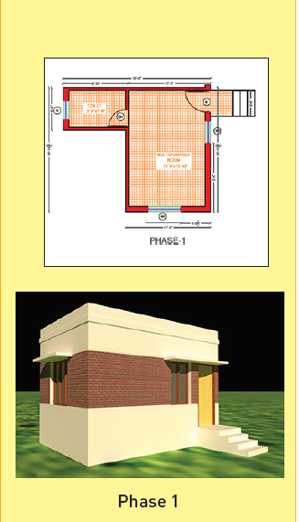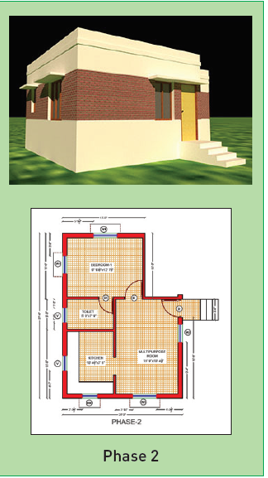
Figure 10: Incremental Build Plan - Secured Loan - Phases 1 & 2

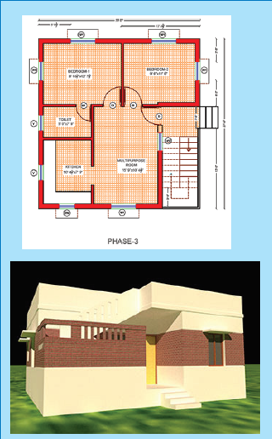
This incremental build model would lead to a 700 sq ft house in 3 phases and can be used when a client is eligible for secured lending.
Figure 11: Incremental Build Plan - Secured Loan
Loan amount will need to be disbursed in tranches, following utilisation checks
 | Plan | Area | Estimated cost
Phase 1 | 1 multipurpose room + 1 bathroom, toilet | 250 sq ft | Rs.312,500
Phase 2 | 1 bedroom + 1 kitchen | 250 sq ft | Rs.312,500
Phase 3 | 1 bedroom + staircase | 200 | Rs.290,000

This method of building incrementally ensures that the family can move in and start using the new structure. They can then expand the home as they become eligible for the next loan. The repeat loans could also be a motivating factor to limit expenses to the loan amount. Any savings or subsidy received would go to reduce the liability of the household.

Policy Recommendations

According to Mc Kinsey’s Global Institute Analysis, the 3 main themes in policy that could help improve access to housing are a) to Reduce Loan origination cost, b) to Reduce cost of funding mortgages or housing microfinance and c) to leverage collective savings to reduce rates.
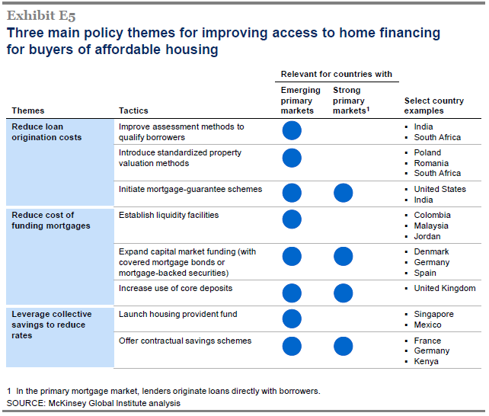
Figure 12: Main Policy Themes to increase access to Housing

Policy Interventions – National Housing Bank

In order to promote affordable housing NHB has brought in some policy decisions like introducing Refinance for Affordable Housing by creating the Affordable Housing Fund. Setting up Central Credit Risk Guarantee Fund Scheme (CCRGFS) for Low Income Households, notified in 2012, which provides support to collateral-free or third party guarantee free new individual housing loans was also a good initiative. Also NBFC MFIs seem included in the list of eligible entities.

NHB has indicated acceptance of ‘Alternate Security’ as shown below for two of its Refinance schemes for housing loans – i.e., Affordable Housing Fund (AHF) and Special Urban Refinance Scheme for Low Income Households (SURSLIH).

- “Security to be obtained from individual borrowers - The individual housing loans may be secured either by mortgage-able title over the land / property or by alternate security to the complete satisfaction of the PLI.
- The credit risk of the primary loan will be fully taken by the primary lending institution and the refinance sought from NHB would be repayable irrespective of the primary loan account remaining regular or otherwise.
- Further, in cases where PLI accepts alternative security for loans under the scheme, it is to be ensured that the borrower enjoys a minimum right of tenure in order to avoid legal challenge and loans to be lost following the eviction of borrower.”

Apart from this, the Government has given a big push to addressing housing shortage in the form of PMAY – Housing for All by 2022, and has included options like CLSS (Credit Linked Subsidy Scheme) and BLC (Beneficiary linked Construction), which could benefit the segment.

The Jan Dhan scheme for opening bank accounts is also a great help to motivate banks to open individual accounts for the Low Income group, albeit without cheque books, which are now easily convertible to regular accounts. This benefits lenders who would like to target this segment with means of not disbursing funds and receiving collections, but also for tracking savings to indicate financial discipline.

Challenges in Implementation – NHB

NHB’s Refinance is only available to Housing Finance Companies and only for mortgaged individual loans. The channel for reaching the EWS & LIG segments is clearly Microfinance Institutions (NBFCs regulated by RBI), which seem to have been left out of the equation. Also, while 86% Housing Microfinance clients have ownership of their property, the documentation to prove it might not be in the format needed for mortgage (as opposed to the general understanding that EWS & LIG clients have no ownership rights to their property). In discussions with Housing Finance Companies and Small Finance Banks looking at this space, there seems to be very little awareness about ‘Alternate Security’’ and the ease with which refinance could be obtained using it.

On-lending interest rate cap (MCLR plus 100 bps for Scheduled Commercial Banks and NHB Refinance Rate plus 350 bps for others, which was subsequently raised to 6%) is a deterrent to institutions seeking refinance. Only very large institutions could operate within this margin, and are not likely to be interested in lending to the Low Income segment.

The Credit Guarantee scheme faces a similar issue – in that one can borrow at 3%, but lend at 6%, which is not enough spread to cover acquisition cost and to build necessary reserves to manage credit risk in this segment.

Challenges in Implementation – PMAY

On account of the following challenges, these subsidies are having a difficult time reaching the segment that needs them the most.

CLSS – Credit Linked Subsidy Scheme

In this case, interest subsidy is credited directly to the borrower’s account through the Primary Lending Institution (PLI).

Not many HFCs are lending in the loan ticket size Rs.3 to 6 lakhs with barely 2 – 3 such institutions and a few more who would like to get into the segment. NBFC-MFIs seem to be included as Primary Lending Institutions, but are not actively lending in that ticket size either.

Only Rs.3000 is allowed as expenses to the PLI as opposed to a typical 1.5% processing fee for loans less than Rs.6 lakhs. These loans, as has been discussed already cost more to acquire and process.
An approved plan is mandatory, while AHFCs do not normally insist on this. There is little awareness and fewer resources in this segment to acquire such a plan.

Beneficiary-led construction

While Rs.1.5 lakhs is not enough to build a house, the expectation is to demolish and start construction before actual release of funds. Besides, funds are released in tranches on completion of phases. For households who lack a pucca home, there would most likely be no funds to start with.

Institutions interested in lending to start work or to meet the difference are unable to co-ordinate lending with subsidy. Only a list of applicants is available, no list of beneficiaries to be able to reach prospective beneficiaries with loan or awareness-building exercises.

In some cases, beneficiaries have been caught in the middle left with no place to stay after demolishing their homes – which would be the direct opposite of what was intended for them.

In RBI’s bulletin dated 10th January 2018, the effect of CLSS on affordability was compared across segments and here’s the conclusion that was arrived at. “CLSS has been found to make housing more affordable to the EWS segments through an empirical study and therefore the segment should be given priority”. However, this is the segment that could be harder to reach out to.

RBI initiatives

Here are initiatives by the RBI that are intended to increase liquidity and rationalise regulation for HFCs and other channels to reach the affordable housing market:

RBI has allowed banks to issue long term bonds (minimum 7 years maturity) for affordable housing, which is however defined as houses valued up to Rs.50 or even Rs.65 lakhs.

Banks have been allowed to provide home loans up to 90% for properties that are less than Rs.30 lakhs.

Provisioning or risk-weight norms for home loans have been modified (standard asset provisioning has been reduced from 0.4% to 0.25%) to make them cheaper.

RBI is now the regulator for Housing Finance Companies. Already being the regulator for NBFC-MFIs, they would be in a position to ensure that both types of institutions are able to work hand-in-hand to reach the LIG segment.

Reducing the exposure of Housing Finance Companies to project finance is a welcome move, in the light of recent debacles. This will motivate HFCs to focus on individual loans and the low income segment.

Recent RBI norms for HFCs – in terms of increased capital however, is not suitable for small HFCs focused on EWS and LIG segments who have less investor interest.

Impact

In the face of the above initiatives it would be important to track results in the field. Such periodic review will help fine-tune policies to ensure that not just target numbers, but targeted impact is achieved as well. In fact, looking at the potential size of the target segment, it would only be a short while to achieve numbers, once it is ensured that access is enabled to them.

Here are the charts showcased in RBI’s bulletin dated 10th January 2018.

Figure 13: Housing Loans Disbursed

In 2016-2017, assuming average loan size of Rs.500,000, approximately 859,800 loans were disbursed in the less than Rs.10 lakh category. Cumulatively around 2.18 mn loans seem to have been disbursed as against the need of 38 mn housing units projected for 2022 for the urban market alone.

This therefore leads us to ponder on the following points:
a) Are these the right channels to reach the vast unreached market (EWS & LIG segments) if we were really looking to ensure housing for all by 2022?
b) Is the definition of ‘Affordable housing’ being widened simply to reach desired numbers?

Looking at the chart quoted in RBI’s bulletin dated 10th Jan 2018, only about 200,000 loans have been refinanced in the category ‘up to Rs.2 lakh loans’.

Only Rs.49,380 loans have been refinanced in the category Rs.200,000 to Rs.500,000 loans.

Figure 14: Refinance Disbursements
This begs the question, “Do loans over Rs.25 lakhs (43.6%) need refinance at subsidised rates”?
Reports show that there are 10 mn vacant houses lying unutilised. However, NHB’s Rs.30,000 crore refinance fund could make a substantial difference in the Low Income housing segment. Priority Sector lending targets for housing for NHB and other HFCs are the need of the hour. Ideally refinance and credit guarantee funds need to be set aside and targeted at the bottom of the pyramid through the right channels, so that more lenders enter the segment and end clients can benefit.

Possible Solutions – National Housing Bank

It would be important to classify Housing Finance Companies into ‘LIG, Affordable and Other’ HFCs, with targets to achieve, customized terms and separate pools of refinance fund. That way, it can be ensured that each segment – especially the ones targeting the lower end of the market get their share of attention and funds.

Once classified, the funder needs to actively engage with the ‘LIG HFCs’ to ensure that there is regular flow of funds to the EWS and LIG segments at subsidized rates. These institutions should be allowed to use ‘Alternate Security’ suitable for the segment for refinance purposes.

Apart from this, as has been seen, unsecured home improvement loans play a large part in making homes of the LIG segment live-able and is a segment in itself for which funds need to be assured. Where clients have secure tenure (right to stay) and it can be verified that the loan was utilized for home improvement, using utilization checks, such loans disbursed by Microfinance Institutions backed by HFCs of SFBs need to be declared as ‘housing loans’ and included in the refinance scheme. Funds for capacity building needs to be built into this, to ensure that the loans are suitably designed, credit risk managed and are impactful in the field.

Credit Guarantee needs to be targeted at institutions lending in the Rs.2 to 6 lakh ticket size (LIG HFCs, SFBs), allowing reasonable margin and ability to take third party guarantee, since it would be imprudent to give out a loan with neither collateral nor guarantee. As experience is built in this segment, the credit guarantee could be made operational in the case of unexpected perils or one-off events that could potentially hurt the portfolio. This would break entry barriers and encourage institutions to enter the space and also build capability along the way.

Guidelines need to be set, achievement of targets tracked and recognized based on income levels of beneficiaries, rather than ticket size alone. That will ensure that housing reaches the target segment rather than going to speculative investors.

NHB could also actively encourage the development of innovative savings-linked products for all segments, weaning the country away from a credit culture. Now that SFBs have the ability to offer liability products, so many more avenues and product types open up. With their experience of having worked with the LIG segment in their MFI avatar, they would be excellent candidates for such products.

- Funds made available at concessional rates by international development organisations like FCDO- UK, AFD-France and IFC for green housing, need to be used for the purposes for which they were received, rather than be used for investment in treasury instruments and public sector bonds.

Working closely with grass root organisations will ensure that communities are involved in finding suitable housing solutions for themselves. Keeping that channel of communication open will empower them and give them dignity, apart from offering them real solutions. It will also bridge the gap between policies and their actual implementation in the field, which could take housing for the bottom of the pyramid to a whole new level.

Possible Solutions – PMAY – Housing for all

While this scheme has been lauded at various levels, constraints have made it hard for the target population to benefit from it.

CLSS needs to be targeted at channels that will reach the EWS and LIG segments – like Small Finance Banks and ‘LIG HFCs’, either directly or channeled through Microfinance Institutions. Also, these institutions will need to be able to charge a normal processing fee, which could perhaps be subsidized.

Working with such institutions closely will open up doors to making this scheme available to the people who need it the most, resulting not just in achievement of target numbers, but actual houses that are used and upgradation of entire cities and villages.

A pre-approved list of beneficiaries eligible for subsidy under BLC could be released. Apart from making the whole process transparent, this will enable lenders to identify them and offer them suitable gap funding, without jeopardizing their portfolio. Families will also be able to pursue avenues that will help them build their homes. Client counseling or awareness building could also be targeted at such clients.

Also channeling the subsidy for beneficiary-led-construction (BLC) through lending institutions will help reduce end client liability and better planning. That the way the institution could include the subsidy while calculating the client’s eligibility, enabling the client to plan for a suitable size dwelling rather than start off with uncertainty.

The need for an approved plan could be removed, as it poses a hurdle to reaching this segment. However, the importance of properly designed homes with good ventilation, disaster resilience and green principles, needs to be communicated in the form of awareness creation not just among end clients, but among masons as well. Funds will need to be made available for this purpose and the support of suitably experienced organizations utilized.

Land records are an important piece in the puzzle of how to reach the LIG segment with suitable funds and services for housing. This would mean negotiating with states on strengthening land records. This needs to be coupled with promoting regularization of property ownership, simplifying related documentation and rebates in stamp duty and mortgage registration fee – more so for this segment. Lowering stamp duty will lead to higher compliance, bringing more transactions into the light and thereby increasing revenue.

Conclusion

Housing is a basic need and although challenges abound, suitable solutions need to be found.

Institutions like MFIs and SFBs with their experience with the LIG segment and Housing Finance Companies with decades of experience in housing and its intricacies could work together in various models to reach the underserved Low Income group with suitable products and solutions that will meet the need for decent housing. Sharing experience and capacity building will be a big part of this, so that institutions can take calculated risks. Roping in the community it is meant for, will make the solutions relevant and practical.

The support of all stakeholders, especially funder NHB and the regulator RBI, not to mention government agencies, could encourage institutions wanting to enter the LIG space by providing necessary low cost funds not just for on-lending, but also for capacity building at institutional level and awareness creation at the end client level. Tying in insurances and guarantees will also protect the segment.

There have been a few recent initiatives that seem promising – like government’s intention to conduct drone surveys and give property ownership cards that could be used to prove ownership for borrowing. Recently a special liquidity scheme to manage a Stressed Asset Fund (SAF) for NBFCs and HFCs was announced to improve their liquidity position.

However, a more strategic and cohesive set of initiatives built by collaborative means will help institutions align themselves to reach the underserved market, apart from pro-actively anticipating pitfalls and avoiding them.

Together, the above could lead to ‘housing for all’ truly as envisioned, while building a robust housing market in the country, which could be a model for other countries to follow.

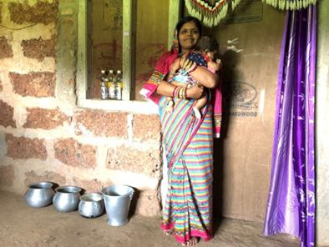

https://www.nhb.org.in/Whats_new/nhbwebsiteupload/Low%20Income%20Housing-study%20Sponsored%20by%20NHB%20&%20World%20Bank%20.pdf
https://www.ifc.org/wps/wcm/connect/news_ext_content/ifc_external_corporate_site/news+and+events/news/home+improvement+financing+india
Global Housing Microfinance Survey 2015-16, by Terwilliger Centre for Innovation and Shelter, Habitat for Humanity International
ICRA Report on Affordable Housing Finance Market in India (September 2017)
Source: State of the Low Income Housing Finance market 2018. https://www.urban-industrial.in/hrdpmp/igep-uid/content/e15/e1533/e1534/e4479/e4480/e4543/Stateofthelow-incomehousingfinancemarket2018.pdf
https://www.rbi.org.in/Scripts/BS_ViewMasCirculardetails.aspx?id=9827
As per the new notification, registered non-banking financial companies ('NBFCs') with assets worth INR 100 crore or more now qualify as 'financial institutions' under SARFAESI, and are entitled to enforce security under SARFAESI for secured debts of INR 50 lakhs and above.
Source: Economic and Political weekly; Journal » Vol. 51, Issue No. 24, 11 Jun, 2016 » India's Residential Rental Housing
Source: https://nextbillion.net/the-pyramid-within-the-pyramid/
Merril and Mesarina. 2007. Expanding Microfinance for Housing. (Micronote #26). Online USAID publication. Available at: www.microlinks.org
Microfinance Pulse Report: VOL II; JUNE 2019 (EQUIFAX-SIDBI Publication)
Housing Support Services are nonfinancial services intended to equip families or the suppliers of housing materials or services with knowledge, connections or other resources that will improve the quality or reduce the cost of solutions built.
Source: https://nhb.org.in/wp-content/uploads/2016/10/Booklet-on-Refinance-Schemes-of- National-Housing-Bank.pdf
Please refer NHB website for the latest on-lending rate cap
https://www.newindianexpress.com/states/karnataka/2020/sep/03/dreams-of-a-house-come-crashing-down-tribals-stay-in-toilets-cattle-sheds-in-karnataka-village-2192063.html
https://www.jll.co.in/content/dam/jll-com/documents/pdf/research/apac/ap/in_affordable%20Housing-ICC_feb_16.pdf

